

NATIONAL UNIVERSITY OF TECHNOLOGY
(Department of Computer Science)
CS161– Database Systems
Instructor: miss Faiza Jan
Name: Bisma Fatima
Roll no: f24605036

LAB TASK 07
In Lab Tasks
Scenario:
An online bookstore needs a database to manage its inventory, customer information, and order history. The bookstore wants to track books, customers, orders, and the items included in each order.
Entities and Attributes:
∙ Books:
o BookID (INT, Primary Key)
o Title (VARCHAR)
o Author (VARCHAR)
o ISBN (VARCHAR, Unique)
o Price (DECIMAL)
o StockQuantity (INT)
∙ Customers:
o CustomerID (INT, Primary Key)
o Name (VARCHAR)
o Email (VARCHAR, Unique)
o Address (VARCHAR)
∙ Orders:
o OrderID (INT, Primary Key)
o CustomerID (INT, Foreign Key referencing Customers)
o OrderDate (DATE)
o TotalAmount (DECIMAL)
∙ OrderItems:
o OrderItemID (INT, Primary Key)
o OrderID (INT, Foreign Key referencing Orders)
o BookID (INT, Foreign Key referencing Books)
o Quantity (INT)
o Price (DECIMAL) -- Price per item at the time of order

Task 1
▪ Database and Table Creation:
∙ Create a database named "BookstoreDB".
Write and execute SQL queries to create the Books, Customers, Orders, and OrderItems tables as described above, ensuring appropriate data types, primary keys, and foreign key relationships are defined.
Query to create database

Query to creating book table
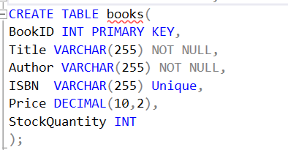

Query to creating Customer table
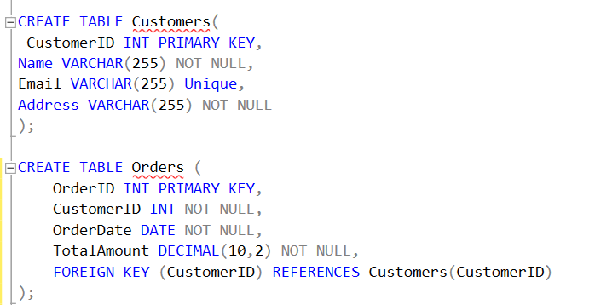

Query to creating Orders table


Query to creating OrderItems table

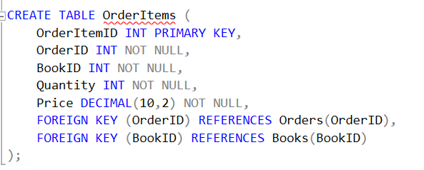

Explanation of Create query :
Database and Table Creation
1. Create Database: Use the CREATE DATABASE statement to create a new database named "BookstoreDB".
2. Define Tables: Create four tables: Books, Customers, Orders, and OrderItems, each with relevant columns and data types.
3. Primary Keys: Define primary keys for each table to uniquely identify records (e.g., BookID, CustomerID, OrderID).
4. Foreign Key Relationships: Establish relationships between tables using foreign keys (e.g., OrderID in OrderItems references Orders table).
5. Execute Queries: Run the SQL queries to create the database and tables with defined structures and relationships.

▪ Data Insertion:
∙ Write and execute SQL queries to insert sample data (Book store data.txt) into each of the tables. Insert at least 5 books, 5 customers, 5 orders (with associated order items), making sure that the data adheres to the defined relationships.

Query for inserting data in book table

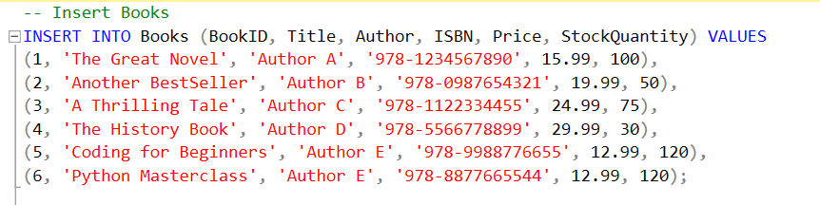

Table form

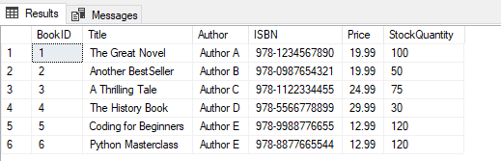

Query for inserting data in Customer table
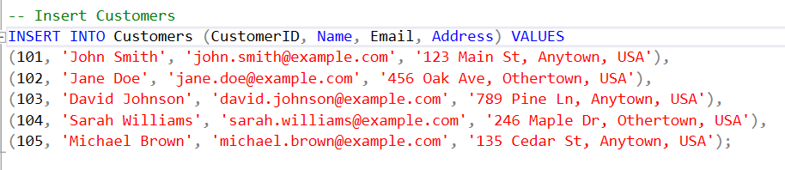

Table form

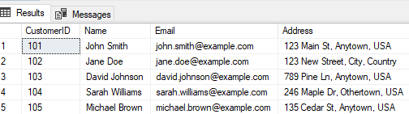

Query for inserting data in Orders table

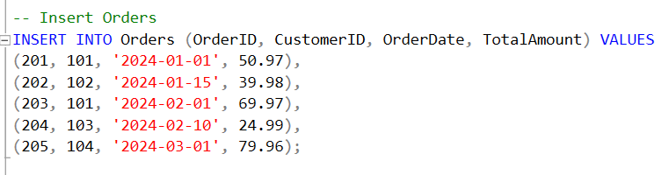

Table form

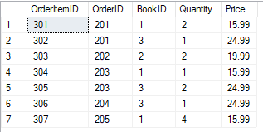

Query for inserting data in OrderItems table
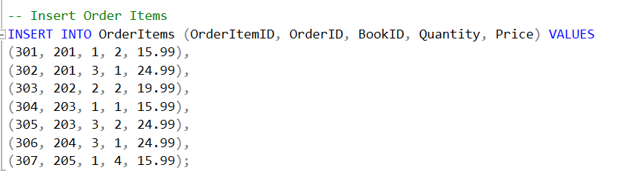

Table form

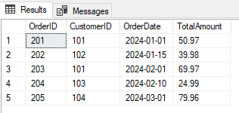

Explanation of insertion query :
Data Insertion
1. Prepare Sample Data: Gather or create sample data for books, customers, orders, and order items.
2. Insert Data into Tables: Use INSERT INTO statements to add data to each table, ensuring data consistency and adherence to relationships.
3. Books Table: Insert at least 5 books with relevant details (title, author, price, etc.).
4. Customers and Orders: Insert 5 customers and 5 orders, linking orders to existing customers.
5. OrderItems: Insert order items for each order, referencing existing books and orders.

▪ Data Retrieval:
∙ Write SQL queries to retrieve the following information:
o All book titles and authors from the Books table. For example: SELECT Title, Author FROM Books;

query for selection of title, Author

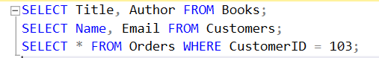

Result of selection query

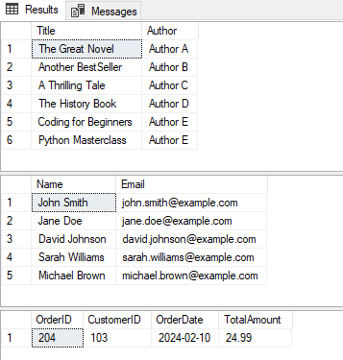

o The names and email addresses of all customers from the Customers table. For example: SELECT Name, Email FROM Customers;

query for selection of name, email



Result of Query



o All orders for a specific customer (e.g., CustomerID 103).

Query to selction of data on specific condition


Result of Query


Explanation of Selection query :
Data Retrieval Queries
1. Retrieve Book Information: Use SELECT statement to fetch book titles and authors from the Books table.
2. Customer Details: Retrieve customer names and email addresses from the Customers table using SELECT.
3. Specific Customer Orders: Use SELECT with a WHERE clause to fetch orders for a specific customer (e.g., CustomerID 103).
4. Joining Tables: Consider using JOIN clauses to retrieve related data from multiple tables (e.g., orders and customers).
5. Query Examples:
- SELECT Title, Author FROM Books;
- SELECT Name, Email FROM Customers;
- SELECT * FROM Orders WHERE CustomerID = 103;

▪ Data Modification:
∙ Write SQL queries to perform the following modifications:
o Update the price of a specific book (e.g., BookID 1) in the Books table.

Query to update Price where BookID=1
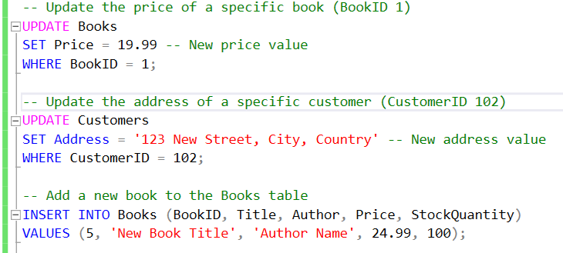
Update form

o Update the address of a specific customer (e.g., CustomerID 102) in the Customers table.

Query to update Price where CustomerID=102



Update form

o Add a new book to the Books table.

Query to update/insertion of new data



Explanation of Update query :
Data Modification Queries
1. Update Book Price: Use UPDATE statement to change the price of a specific book (e.g., BookID 1) in the Books table.
2. Update Customer Address: Use UPDATE statement to modify the address of a specific customer (e.g., CustomerID 102) in the Customers table.
3. Insert New Book: Use INSERT INTO statement to add a new book to the Books table.
4. Modify Order Quantity: Use UPDATE statement to change the quantity of a book in an order, potentially involving the OrderItems table.
5. Query Examples:
- UPDATE Books SET Price = 19.99 WHERE BookID = 1;
- UPDATE Customers SET Address = 'New Address' WHERE CustomerID = 102;
- INSERT INTO Books (Title, Author, Price) VALUES ('New Book', 'Author Name', 14.99);
- UPDATE OrderItems SET Quantity = 3 WHERE OrderID = 1 AND BookID = 1;

▪ Data Deletion
∙ Delete a specific order and its order items.
o Delete a customer.

Query to Delete from OrderItems where OrderID=300

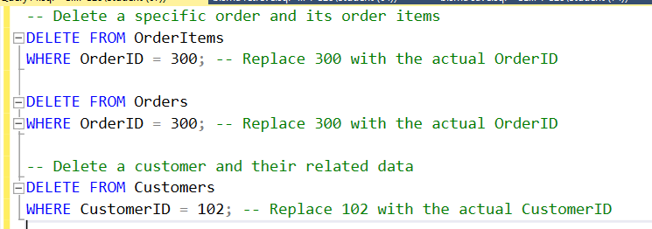

Query to Delete from Orders where OrderID=300


Query to Delete from Customers where OrderID=300


Explanation of Delete query :
Data Deletion Queries
1. Delete Order Items: Use DELETE statement to remove order items associated with a specific order.
2. Delete Order: Use DELETE statement to remove the order itself.
3. Delete Customer: Use DELETE statement to remove a customer, considering potential foreign key constraints.
4. Cascading Deletes: If foreign key constraints are set up, deleting a parent record (e.g., order) might automatically delete related child records (e.g., order items).
5. Query Examples:
- DELETE FROM OrderItems WHERE OrderID = 1;
- DELETE FROM Orders WHERE OrderID = 1;
- DELETE FROM Customers WHERE CustomerID = 102;

